AS 403 COURSE SYLLABUS
SP 08
Preparation for Active Duty
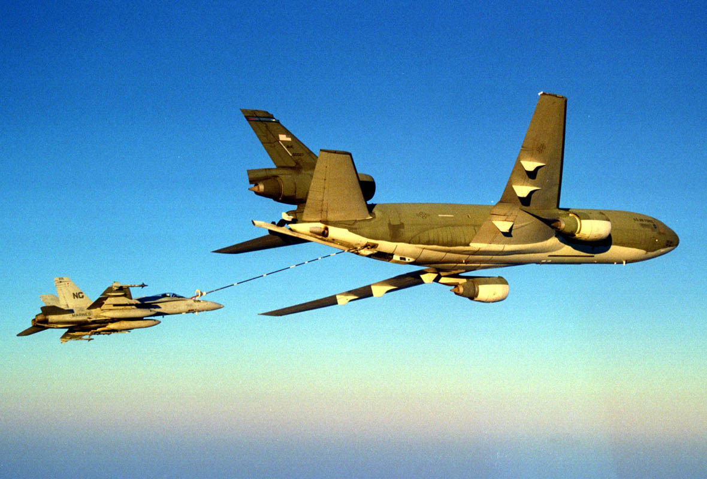
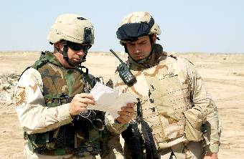
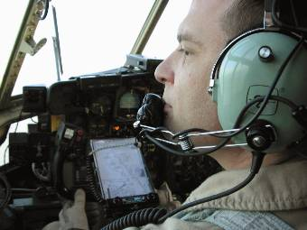
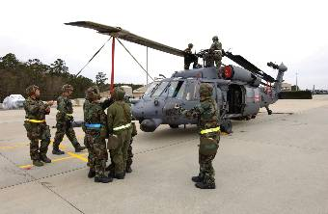

COURSE MEETING TIMES: Tues & Thur 0700 - 0818

INSTRUCTOR: Capt Bill Holl
Office Phone: 292-5441

E-mail: holl.8@osu.edu
Office Hours: By appointment or whenever instructor is available

WELCOME BACK! This class focuses on final preparation for active duty.

COURSE GOAL
- Be prepared to enter active duty as a 2d Lt

GENERAL: General course instructions regarding academic and classroom policies are found in the Aerospace Studies General Course Instructions attached to this syllabus. Note: You must also complete a quarterly counseling with the instructor by 25 Apr 08.

ATTENDANCE & PARTICIPATION (A&P): A&P are 10% of your final grade. Participation includes asking/answering questions, leading class discussions, and your overall attendance. A minimum of 80% class attendance is MANDATORY for a passing grade. If a conflict arises, please coordinate the excused absence with me before the class period. Any uncoordinated absences will result in an unexcused absence. NOTE: You must prepare for class and actively participate in the classroom discussions to receive class participation credit. Respect the ideas expressed by others.

REQUIRED TEXTS & OTHER COURSE MATERIALS:
- National Security Affairs & Preparation for Active Duty (T-408)
- Flyby booklet
- Tongue & Quill (AFH 33-337)
- Computer Based Training (CBT) CD
- SERE 100 – Level B Training CD
- Vantage Points
- Heir Power

SUPPLEMENTAL: Supplemental material may be passed out during the quarter. You will be told what is testable in the additional material. Additional Samples of Behavior (SOBs) may be assigned as well.

GRADING CRITERIA:

Exam 1 30%
Exam 2 30%
Written Assignments 10%
Quizzes 10%
Computer Based Training 10% (SERE-100 Level B)

Class Participation 10%

Total 100%

ASSIGNMENTS:

a. Exams: There are two exams with each covering about half of the material presented in class. If you can answer the Samples of Behavior listed at the beginning of each lesson in your Study Guide you should do well on the exams.

b. Written Assignments: I will give you several short written assignments during this quarter to include:
- Case Studies
- OPR/EPR bullets

c. Quizzes: I will give quizzes on your Flyby booklet, which will count for 10% of your final grade.

d. Preparation for class: The study assignments for the lessons covered in class are listed in your Cadet Study Guide.

WEARING THE UNIFORM: Wear your uniform to class on Thursday unless excused by the instructor. Comply with Air Force and AFROTC Instructions on proper uniform wear.

AS 403 SCHEDULE

Note: Lessons with an “XX” are not in your main book (though part of the material may be covered in your Flyby booklet).

DATE | LSN | TITLE
25 Mar | XX | USAA: Financial Education (Mr. Blaine Ross)
27 Mar | 28 | Law of Armed Conflict (Video)
 | 29 | UCMJ (Reading Assignment) & Assign/Work on Chapter 31 Case Studies
 | CBT 1 | Air Force Complaint & IDEA Program
1 Apr | 28 | Law of Armed Conflict (Lecture)
 | 30 | Military Law & Significance of Article 2, 7, 15, 31
 | FB | Ch 1-1 (For Help With…)
3 Apr | 31 | Military Law Case Studies (Students Present Assigned Case)
 | DUE | GROUP CASE STUDIES
 | FB | 4-5 (Standards)
8 Apr | 37 | The Enlisted Force
 | 47 | NCO Perspective (Video)
 | FB 4-4 | Counseling
10 Apr | 35 | Performance Feedback
15 Apr | 36 | Enlisted Evaluation System (EES)
 | CBT 2 | Officer Force Development
 | FB Ch 3 | Education
17 Apr | 38 | Officer Evaluation System
 | FB | Ch 4-1 & Ch 4-2 (EPR & Recognition)
22 Apr | 39 | Evaluation Concepts
 | CBT 3 | Security Education
24 Apr | 34 | Bullet Statements for Impact
 | 40 | Bullet Statement Practicum Introduction
29 Apr | 40 | Bullet Statement Practicum (Discussion)
 | DUE | BULLET STATEMENTS
1 May | EXAM | MID-TERM
 |  | Assign Chapter 43 Case Studies
6 May | 43 | Sexual Harassment Awareness (Lecture & Discussion)
 | DUE | CASE STUDY QUESTIONS/ANSWERS
8 May | 45 | Suicide Awareness
 | CBT 4 | Substance Abuse Control Program
 | FB | 1-2 (Getting There)
13 May | 46 | Operational Risk Management
 | 48 | Civilian Personnel
 | FB | Ch 1-3, , Ch 1-4, & Ch 1-5 (In-Processing, Signing In, & Finding a Place to Live)
15 May | XX | Housing & TMO
 | FB | Ch 4-3 & Ch 5 (Military Leave System & Benefits)
20 May | XX | Finances 101 & Benefits
 | FB | Ch 2 (You’ve Arrived)
22 May |  | Joint-Service Parade Practice
 | FB | 4-5 (Standards)
 | DUE | SERE-100 LEVEL B CERTIFICATE
27 May | 50 | Oath of Office
29 May | EXAM | FINAL
 |  | (20 classes total)

Flyby Chapters

 | FB 1-1 | For help with…(what organizations to go to for help)
 | FB 1-2 | Getting there
 | FB 1-3 | In-Processing
 | FB 1-4 | Signing In
 | FB 1-5 | Finding a Place to Live
 | FB 2-1 | Your First Day
 | FB 2-2 | What’s Next
 | FB 2-3 | Your Day
 | FB 3-1 | Developmental Education
 | FB 3-2 | Formal Education
 | FB 4-1 | EPR
 | FB 4-2 | Recognition
 | FB 4-3 | Military Leave System
 | FB 4-4 | Counseling
 | FB 4-5 | Standards
 | FB 5 | Benefits
 |  | 16 reading assignments

AIR FORCE AEROSPACE STUDIES
GENERAL COURSE INSTRUCTIONS 07-08

PURPOSE: The purpose of the General Course Instructions are to ensure that all Aerospace Studies students are informed on Air Force ROTC and Detachment 645 academic and classroom policies.

CLASSROOM PROCEDURES:
This instruction provides direction on the following important areas:
- Calling the room to attention:
-- Cadets will call the room to attention when the instructor enters and departs the classroom.
- Eating in the classroom:
-- Cadets are allowed to eat and drink during class if it does not disturb class. If a class is disrupted, the privilege will be taken away. This privilege can also be revoked if it creates a mess in the classroom.
- Attendance:
-- 80% attendance is MANDATORY! Less than 80% attendance will result in a failing grade.
-- Written excuse letters are required within 72 hours of absence to be considered by the instructor as an excused absence. The instructor will make a case-by-case determination whether an absence is excused. Oversleeping and minor illness (unless accompanied by note from a medical professional) will not be considered a valid excuse.
-- Whenever possible, cadets will notify their instructors in advance of any circumstances which may cause prolonged absence from class.
- Tardiness:
-- All students are expected to arrive to class on time. Cadets arriving late will enter the class with minimal disruption and promptly take a seat. The cadet will see the instructor immediately after class to explain the tardiness. Instructors will handle tardiness on a case-by-case basis, but the instructor has the option of giving the student zero participation points for the class.

TESTABLE AREAS: The Samples of Behavior (SOB) for each lesson identify the testable material. The information for each SOB will be included in the reading assignments, instructor lectures, guest speakers, handouts, films, or videos.

FINAL EXAMS: Final examinations will normally be taken by the student at the time published by the university for that particular Air Science course. If a particular Air Science course has more than one offered examination time, students may elect to take the final exam at whichever time is most convenient for them. In the event one of these scheduled times does not fit into the student's overall final exam schedule, he/she may request relief from the instructor, and take the exam in the scheduled exam period for one of the other Air Science courses.

ASSIGNMENTS: Assignments are due on the day indicated. Unexcused late submissions WILL result in a lower grade. This will be dealt with on a case-by-case basis, but normally the assignments will be reduced one letter grade per day late.

REQUESTS FOR EXTENSIONS: Students who experience difficulties in meeting course requirements due to unusual circumstances may request time extensions from their instructors. The instructor will consider each situation on a case-by-case basis. Students MUST comply with the established course-required times until the instructor grants a time extension. In short, make NO assumption that the instructor will automatically grant a time extension.

CLASS PARTICIPATION: Class participation is an important GRADED part of all Air Science courses. This grade is based on your attendance and the instructor's evaluation of your preparation, attention, and active participation in class. Being present may not earn you any class participation points – attendance and active involvement are necessary for participation points. Active participation is an essential element of leadership.

INITIAL AND QUARTERLY COUNSELING: All AFROTC cadets will be counseled by their instructor on a quarterly basis. The higher numbered course instructor will conduct counseling for dual-enrolled students. ALL contract/new cadets should have their quarterly/initial counseling completed NOT LATER THAN the following dates:

Autumn 2007 26 October 2007
Winter 2008 1 February 2008
Spring 2008 25 April 2008

Other students will be counseled by the last day of classes and before the start of final exams, or as stipulated by the course instructor. Additional counseling will be scheduled as required. Special students are invited to schedule counseling sessions if desired.

SPECIAL NEEDS: Any student with disabilities who needs accommodation in this course is encouraged to speak with the instructor as soon as possible to make appropriate arrangements for these accommodations.

GRADING CRITERIA: The grade determination criteria applied to all AFROTC Air Science courses is The Ohio State University standard. It is repeated below for informational purposes.

GRADE PERCENTAGE

A 93 – 100

A- 90 – 92.9

B+ 87 – 89.9

B 83 – 86.9

B- 80 – 82.9

C+ 77 – 79.9

C 73 – 76.9

C- 70 – 72.9

D+ 67 – 69.9*

D 60 – 66.9*

E Below 60*

* - Investigate for Disenrollment

